[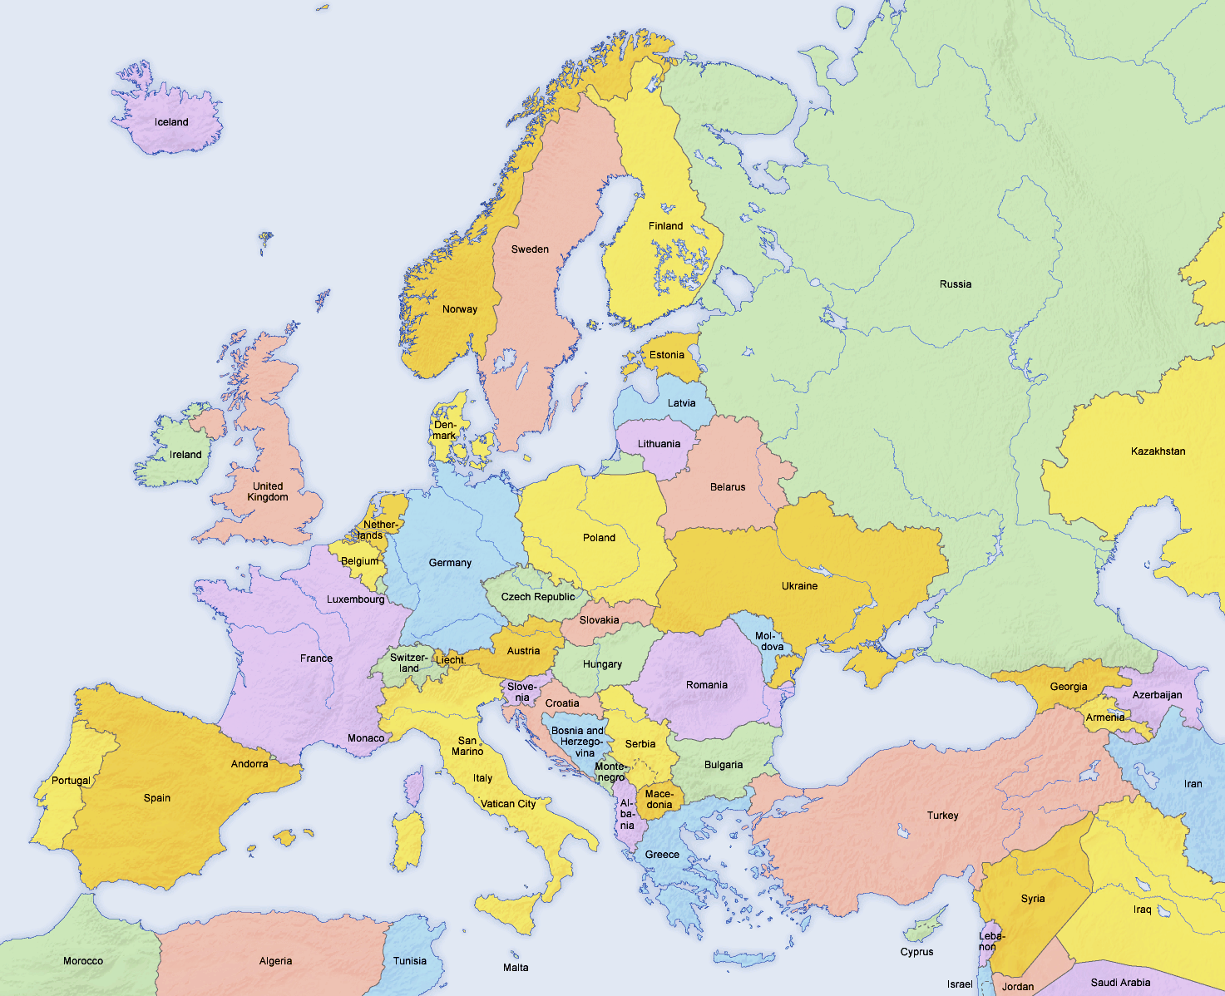](http://www.google.hu/url?sa=i&rct=j&q=&esrc=s&source=images&cd=&cad=rja&uact=8&docid=6pDo1NbTlWZA8M&tbnid=H6i3N7mmSI1YtM:&ved=0CAUQjRw&url=http://en.wikipedia.org/wiki/Europe&ei=hKDaU438FY_04QTqnoCgCQ&bvm=bv.72185853,d.bGQ&psig=AFQjCNGDp7RQVWsOKegC9tc366CgI9pADg&ust=1406923198448582)



CEC 2015 Meeting Budapest 2-nd of August

**Representatives of Austria, Croatia, Serbia, Slovenia and Hungary present**

1.       Next year’s competitions.

* How many legs, (Proposal 4-6) Decision 5 legs.

* in which countries

We checked the intern calendar and considered the competitions in Europe and the qualification tournaments.

1. Kamnik(SLO)25-th of April

2. 16-th of May

3.(CRO) 27-th of June

4. 11-th of July or 22-nd of August

5 (HUN) 12-th of September

*how large area are we covering (proposal 700 km diameter) or we have to count with countries not coming. Decision no more than 700 km diameter and The 3 Founding countries should not be outside this circle.

*new countries interested? Decision: They have to participate 2 years first, than if not too far can organize. Original idea should be kept (as close to each other as possible. Low cost, high level tournaments)

2.       Result lists.

*country code. Club only is not enough. In result list. Decision: Country cod only and the one that used for sports, can find on internet:

CRO, HUN, BIH, SLO,ROM,SVK,POL,AUT, ITA, FRA etc.

*format of results (excel) can not make summaries from PDF ....mistakes are generated unnecessarily. Decision: format sent by Hungary for summaries, every organizer have to fill out the summary within 1 week from competition.

3.       General discussion

*positive effects of CEC for your archers and archery in your country. Easier to get local support for competition for organizer being an international event. Pressure on the line for archers, just as we wanted, higher level every year

*negative effects (hopefully none). Not mentioned during meeting.

       4.     Changes in rules (please send proposal before meeting to everyone) if you have any.( at the moment none)

Proposal for the future from Croatia to have mixed team events. We agree that is a good idea and decide to have the finals as trial next year.

Also it can be a good idea to start 12 a clock on Saturday one night sleep than elimination on Sunday morning.

Send invitation 30 days before event is enough in case of changes. The date is enough to plan for everyone.

       5.     Info ( Homepage ) tell your opinion. Is simple, good as it is.

       6.      Others